Regular paper

A New Extrusion Method for Consolidation of Powders

Ichiro CHOSHA*, Jiro CHOSHA ** and Saburo CHOSHA **
(Received on )

Extrusion is used for consolidation of powders, however, small pores are apt to remain in the extruded compacts. A new extrusion method with large shear deformation has been investigated to minimize such residual pores. In this method, powder is compressed into a cylindrical container and extruded through a die with a rectangular exit, with changing flow direction at a right angle to the compression axis once in the single shear process, or twice in the double shear process. It has been shown that a dead zone is formed at the corner with a right angle in the die and large shear deformation occurs in the vicinity of the corner. The density of compacts extruded with this method is higher than 99 % of that of the material made of ingot. Compared with conventional extrusion, better mechanical properties - higher tensile strength and elongation - can be achieved by this method.

Key words: extrusion, powder forming, metal powder, consolidation, mechanical properties

1. Introduction
Among the various methods for consolidation of powders, extrusion is widely used for P/M production. Recently, extrusion has been used for fabricating metal matrix composites^{1)~3)} and rapidly solidified powders^{4), 5)} However, small pores are apt to remain in the extruded compacts. In the extrusion process, powder is deformed severely at the wall side, but passes through a die without severe deformation near the central portion of a container, as shown in Fig. 1.
After the analysis of the powder flow in the process, metal powders were extruded by this new method and the properties of the compacts produced were compared with those of compacts produced by conventional extrusion.

2. Experimental procedure
2. 1 Shear deformation in a die
The material flow in the die for double shear extrusion is illustrated in Fig. 2. Powder travels through a die with change of the flow direction at a right angle to the preceding flow direction.
Table 1 shows the process conditions for shear extrusion. ************************************************************************************************************************************************************************************************************************************************************************************************************************************.
2. 2 Simple analysis of powder flow
Assuming that the velocities of powder flow in the three zones are V₁ , V₂, and V_{a}, and the cross-sectional areas of the three zones are S₁ , S₂, and S_{a} , we have
$$V_{1}S_{1}=V_{2}S_{2}=V_{a}S_{a}$$ | (1)

* Faculty of Engineering, Sosei University
Y.S.K. Building 4F, 1-3-11 Shibadaimon, Minato-ku, Tokyo 105-0012, Japan
. E-mail: sosei@jstp.or.jp
** Graduate student, Graduate school, Mechanical Engineering, University of Sosei, Y.S.K. Building 4F, 1-3-11 Shibadaimon, Minato-ku, Tokyo 105-0012, Japan

Table 1 Process conditions
Materials |  | A1050
Press |  | Knuckle joint
Process time /s |  | 2.0
Initial temperature /K | Workpiece | 673
 | Punch | 423
 | Die | 423

3. Theory
3. 1 Theoretical check of the incremental inverse
finite-element procedure
As an illustration of the incremental inverse tech-nique, we consider the relationship between the nodal force $\left\{R\right\}$ and the incremental displacement $\left\{dU\right\}$
The nonlinear finite-element equation is expressed as
$\left[K\left(dU\right)\right]\left\{dU\right\}=\left\{R\right\}$.. | (9)
The nodal force based on the bending at the die radius is expressed as⁴⁾.
$$H_{b}=\left\{1+\exp\left(πμ/2\right)\right\}t^{2}Lσ_{y}/\left\{4\left(ρ_{d}+t/2\right)\right\}$$ | (10)
$$d\left[\sum{\frac{1}{2}}m_{i}\left\{{\left(\frac{dx_{i}}{dt}\right)}^{2}+{\left(\frac{dy_{i}}{dt}\right)}^{2}+{\left(\frac{dz_{i}}{dt}\right)}^{2}\right\}\right]=\sum{\left(X_{i}dx_{i}+Y_{i}dy_{i}+Z_{i}dz_{i}\right)}$$ | (11)
Where L and $ρ_{d}$ denote the circumferential length of the inner boundary and the die radius, repspectively.
3. 2 Calculated results and comparison with
experimental results
Experiments were performed on testpieces prepared from sheet metals^{*1}. The experimental data were fitted by an empirical power hardening law of the form
$$σ=σ_{Y}{\left(1+cε_{p}\right)}^{n}$$ | (16)
The coeffcients $σ_{Y}$, c and n are given in Table 2, along with other pertinent data.
Figure 11 shows the experimental and calculated results for the clamping force H vs the deep drawing ratio β,. The calculated forming limit lines for H vs β are shown in Fig. 11 as solid lines. ********************************************************************************************************************************************************************************************************************************************************************************************************************************************************************************************************************************.

Table 2 Materials properties
Material | t  /mm | E  /GPa | $$σ_{Y}$$  /MPa | c | n
Steel | 0.30 | 208 | 296 | 2590 | 0.18
Aluminum | 1.07 | 76 | 80 | 172 | 0.34
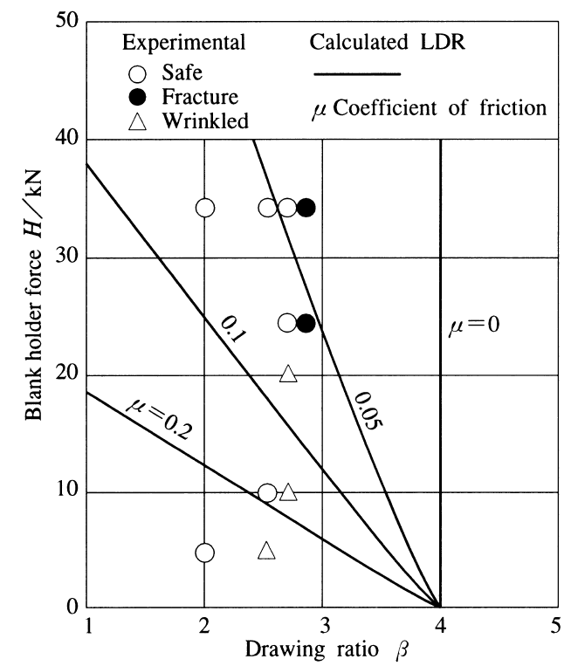

Fig. 11 Comparison of experimental and calculated limiting drawing ratios as a function of blank holder force during the production of square cups from optimum-shaped blanks
*1 The Japan Society of Technology of Plasticity, http://www.jstp.jp/en/, [accessed on Nov. 12, 2019]

***************************************************************************************************************************************************************************************************************************************************************************************************

***************************************************************************************************************************************************************************************************************************************************************************************************

4. Conclusion
Some of the results obtained in the present study show a reasonable correspondence with previously published experimental data on the limiting blank size or deep drawing square cups from optimum blank shapes.

Acknowledgements
The authors thank the Research Council for financial support. All the specimens used in the investigation were provided by Hitashiba Corporation. We thank Mr. E. Williams for his technical assistance.

References
- Aoyama, K.: J. Jpn. Soc. Technol. Plast., 11-108 (1970), 673–677.
- Aoyama, K. & Suzuki, F.: J. Jpn. Soc. Technol. Plast., 20-222 (1979), 620–624.
- Ito, T.: Trans. Jpn. Soc. Mech. Eng., Ser. A, 50-458 (1984), 1732–1736.
- Sowerby, R., Johnson, W. & Samanta, S. K.: Int. J. Mech. Sci., 10-3 (1968), 231-235.
- Hill, S.：Int. J. Mech. Sci., 12-5 (1970), 402–406.
- Sosei, T.: Trans. Jpn. Soc. Mech. Eng., 80-789 (2014), DOI:10.1299/transjsme.2014fe1110.
- Aoyama, K., Tanaka, I. & Sato, T.: Proc. 20th Jpn. Jt. Conf. Technol. Plast., (1969), 250-253.
- Aoyama, K.：Proc. 1991 Jpn. Spring Conf. Technol. Plast., (1991), 250–253.
- Aoyama, K.: Oyo-Sosei-Gaku, (1969), 250–260, Sosei-Sha.
- Wilson, W. R. D.: Adv. Technol. Plast. 1990, (1990), 1667–1670.
- Prager, W.: Theory of Plasticity, 1 (1951), 264–274, Pergamon Press.
- Hanabusa, T.: JP. 1996-242688 (1996)．

